**A CRM Application to Manage the Booking of Co-Living**

**By**

**Suresh Choudhary**

sureshchoudharytrue@gmail.com

**Project Abstract**

The **CRM Application to Manage the Booking of Co-Living** project is designed to make it easier to manage shared living spaces. This app helps people find and book rooms in a co-living space where they can live, work, and connect with others in a friendly environment. The application allows users to select from various air-conditioned rooms with multiple sharing options, customize their daily food preferences, and make payments using various modes. In addition to these functionalities, the application includes features for collecting and analyzing feedback on services such as room cleaning, internet connectivity, and food quality. This feedback mechanism ensures continuous improvement and high satisfaction levels among residents. Overall, the goal of this app is to simplify the booking process, improve the living experience, and help build a strong, connected community.

**Index**

|  |  |
| --- | --- |
| **Topics** | **Page no** |
| Project Abstract | 2 |
| Introduction | 2 |
| Task 1: Object Creation | 2-6 |
| Task 2: Creating Tabs | 6 |
| Task 3: Creating a Lightning App | 7-8 |
| Task 4: Fields & Relationships | 8-9 |
| Task 5: Validation Rules | 9 |
| Task 6: Profile | 10 |
| Task 7: Roles | 10 - 11 |
| Task 8: Creating Users | 11 - 12 |
| Task 9: User Adoption | 13 |
| Task 10: Create Reports | 14 |
| Task 11: Creating Dashboards | 15 - 18 |
| Task 12: Flows | 19 - 20 |

**Introduction**

The **CRM Application to Manage the Booking of Co-Living** is designed to improve the management of co-living spaces. This project aims to create an efficient and user-friendly platform where users can book rooms, select services, make payments, and provide feedback, all in one place. The application focuses on providing a smooth experience for residents while ensuring that co-living spaces are well-managed and foster a sense of community. The app allows customers to choose different types of rooms, select food preferences, and pay through various methods. In addition, users can provide feedback on services like room cleaning and internet connectivity, helping improve the overall living experience.

### Task 1: Object Creation

1. **Total Room**: Tracks the total number of rooms available in the co-living space, including details like room type and capacity.

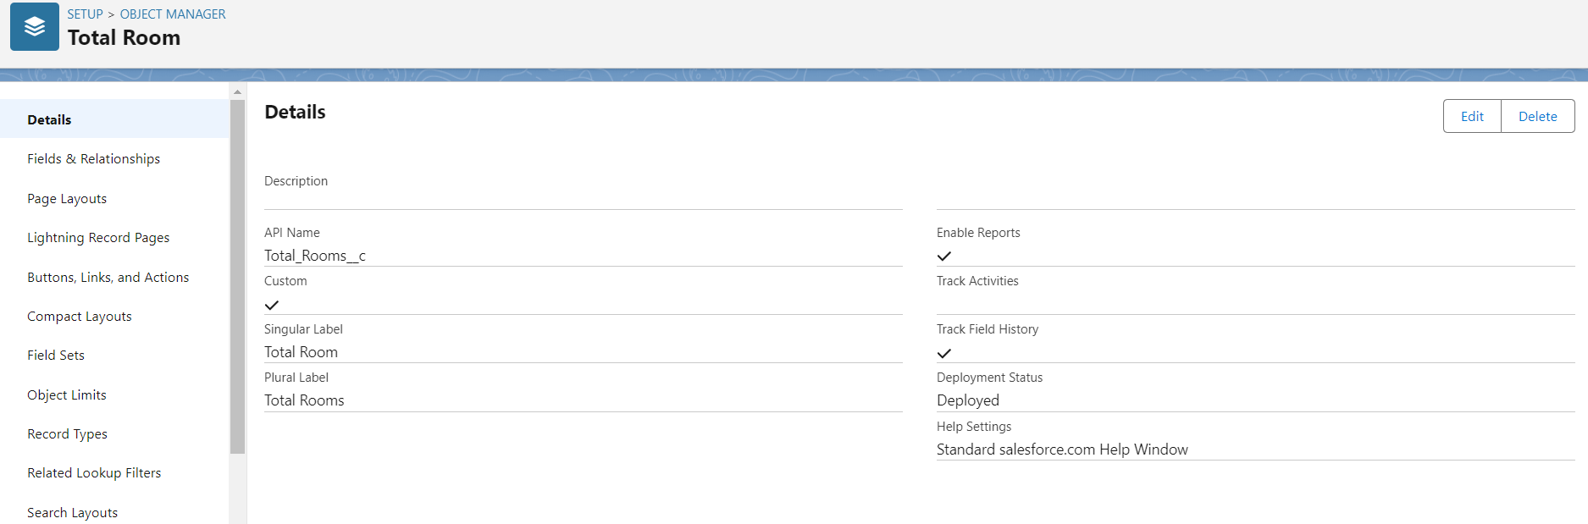

1. **Customer**: Stores customer information, such as name, contact details, and preferences, to manage their bookings and interactions.

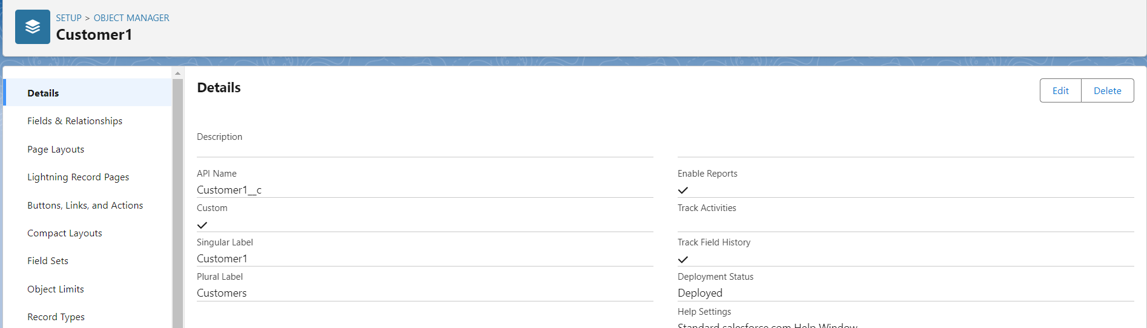

1. **Room Booking**: Manages the booking details for rooms, including check-in/check-out dates, room type, and associated customer.

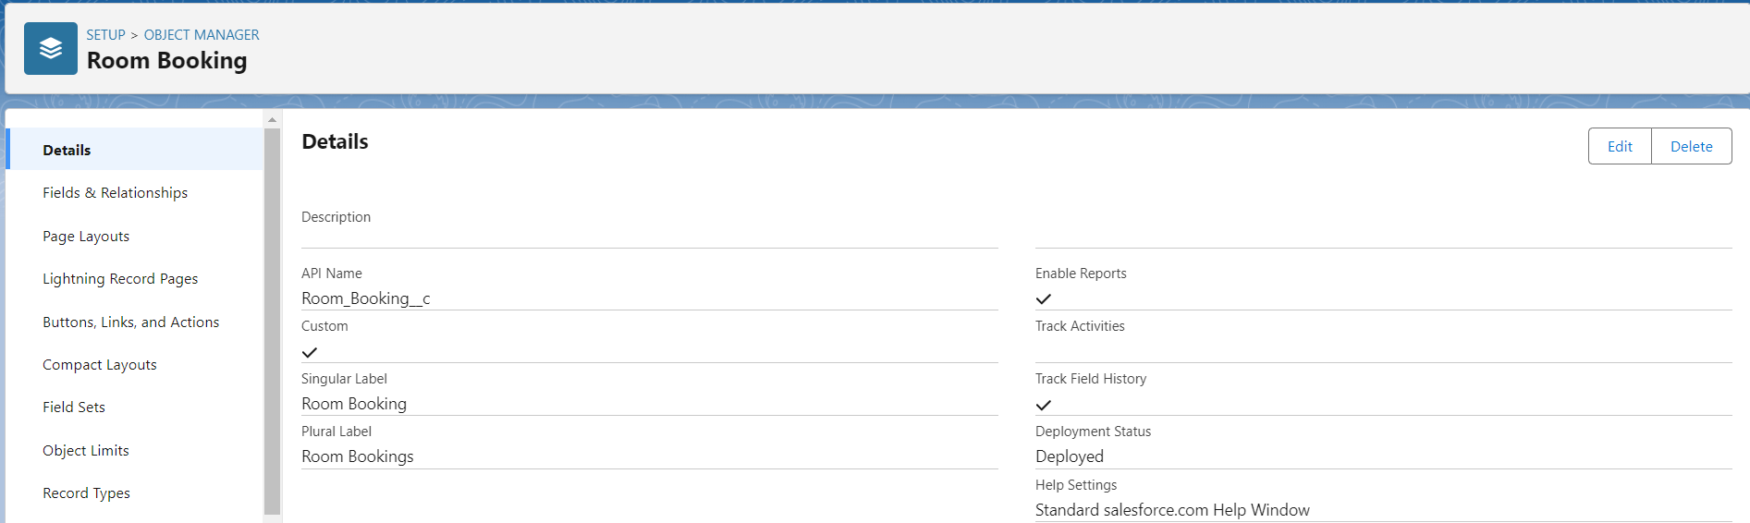

1. **Payment**: Handles payment transactions, including payment mode, amount, and related customer and booking details.

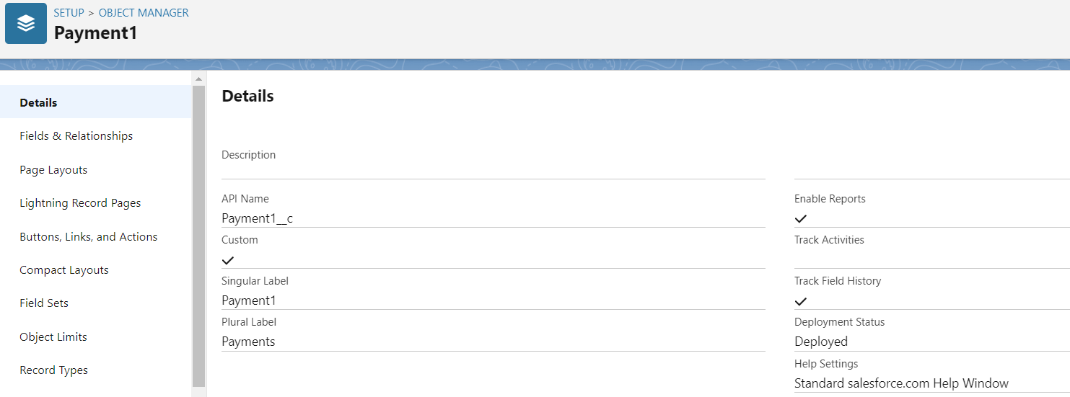

1. **Food Selection**: Allows customers to choose daily food preferences and tracks their selections.

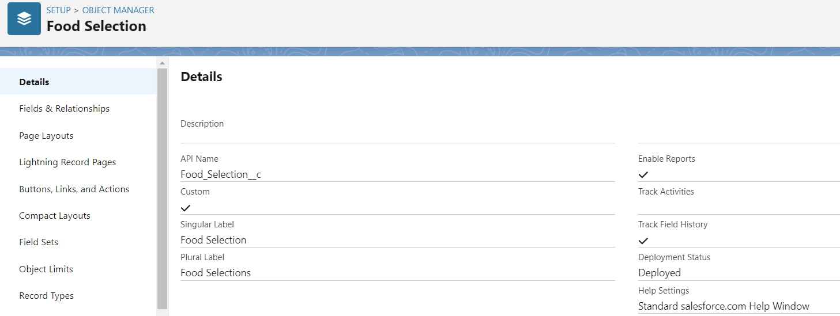

1. **Feedback**: Collects customer feedback on various services like room cleaning, internet connection, and food quality.

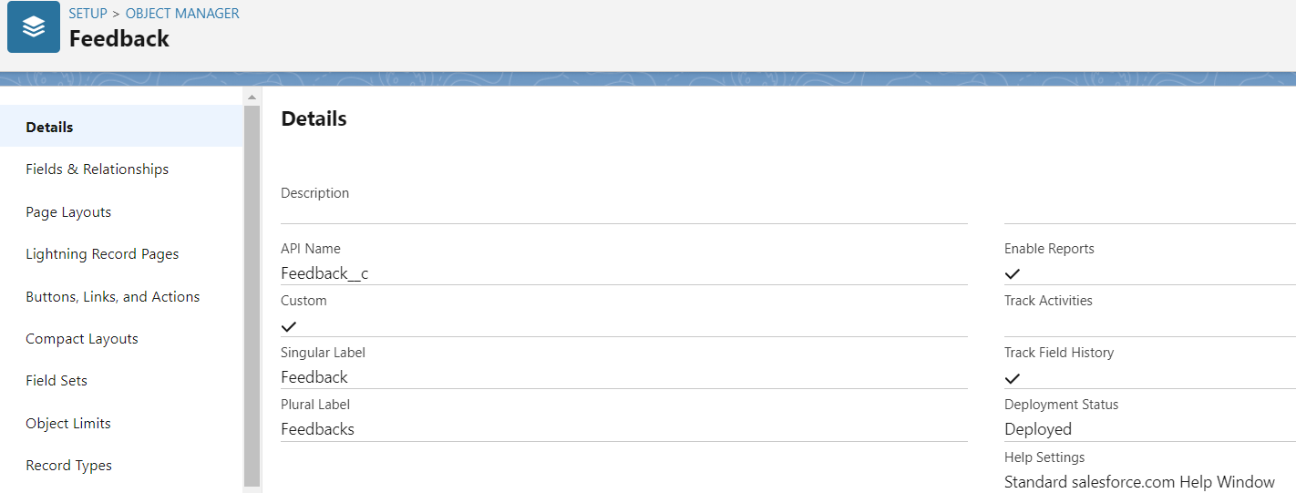

### Task 2: Creating Tabs

1. **Total Rooms Tab**:
   * Create a tab for easy access to the Total Rooms object, allowing users to manage room availability.
   * **Steps**: Go to Setup > Tabs > New Tab, select Total Rooms, and create the tab.
2. **Customers Tab**:
   * Create a tab for the Customer object to view and manage customer details.
   * **Steps**: Follow the same process, selecting Customer.
3. **Room Bookings Tab**:
   * Create a tab for the Room Booking object to manage and monitor room booking information.
   * **Steps**: Create the tab for Room Booking using the same method.
4. **Payment, Food Selection, Feedback Tabs**:
   * Create tabs for each of these objects to facilitate quick access and management of payments, food preferences, and customer feedback.
   * **Steps**: Repeat the steps to create tabs for Payment, Food Selection, and Feedback objects.

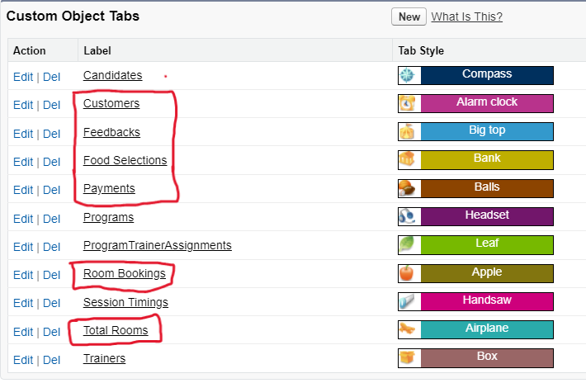

### Task 3: Creating a Lightning App

1. **App Purpose**: Centralize management of Total Rooms, Customers, Room Bookings, Payments, Food Selection, Feedbacks, Reports, and Dashboards.
2. **Steps**:
   * Go to Setup > App Manager > New Lightning App.
   * Enter the app name, proceed with defaults, and move forward.
   * Add navigation items (Total Rooms, Customers, Room Booking, Payments, etc.).
   * Assign System Administrator profile, then save and finish.

Your Lightning App is now set up to manage your co-living CRM efficiently.

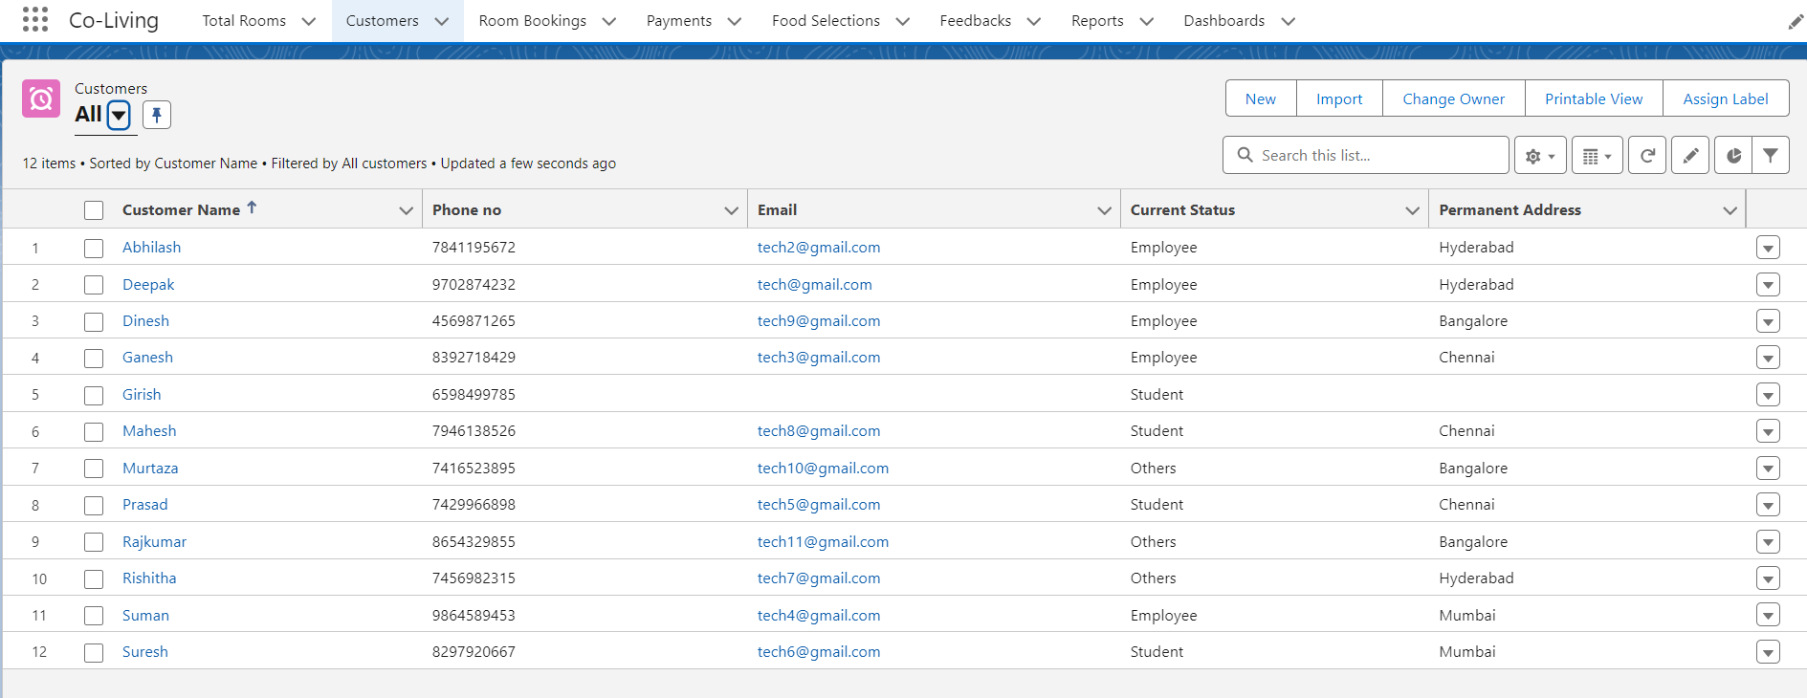

### Task 4: Fields & Relationships

1. **Customer Object**: Create fields for customer details such as Name, Email, Phone Number, and Permanent Address.
2. **Room Booking Object**: Add fields for booking details like Amount, Check-In, Check-Out, Room No., Rooms available, Room Sharing.
3. **Payment Object**: Set up fields for Amount, Payment Mode, Payment No and related Room Booking.
4. **Food Selection Object**: Include fields for Breakfast, Dinner, Lunch, Food Selection No.
5. **Feedback Object**: Create fields for Feedback No, Suggestions, and Service Type (e.g., Room Cleaning, Internet).
6. **Total Rooms Object**: Add fields for Room Available, Room Booked and Total no of Rooms.

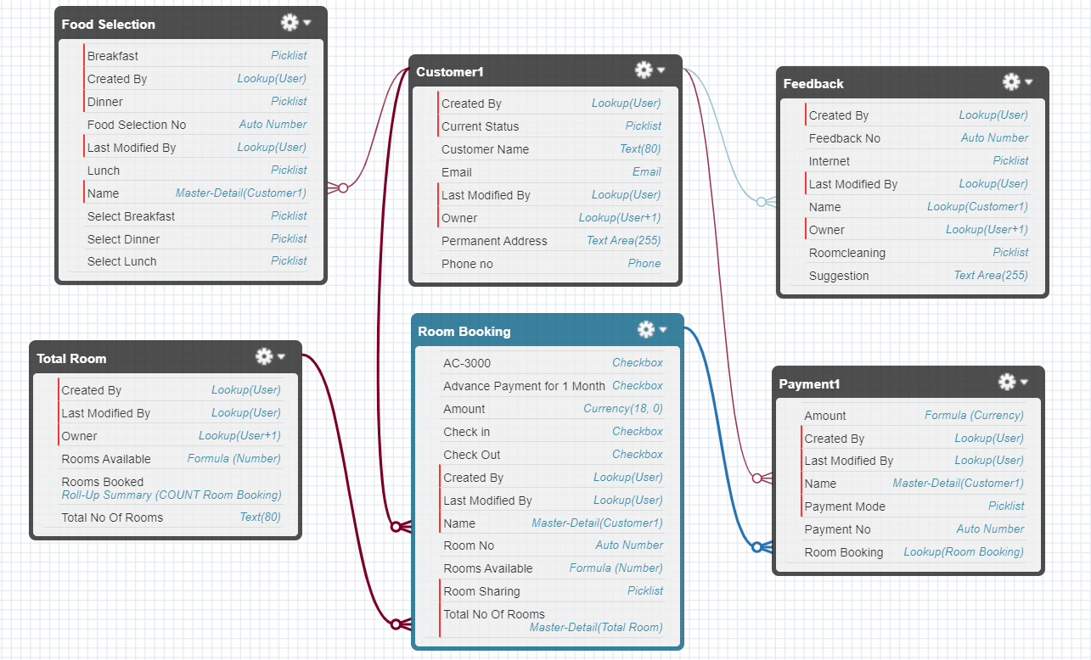

### Task 5: Validation Rules

1. **Validation Rule for Room Booking Object**
2. **Another Validation Rule for Room Booking Object**

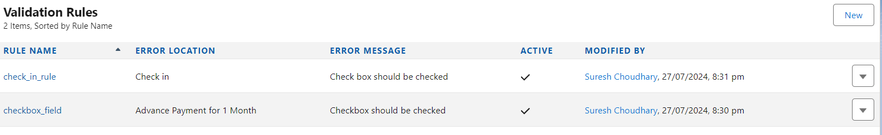

### Task 6: Profile

1. **Custom User Profile**:
   * **Purpose**: Define a profile with access to specific objects and permissions tailored to your needs.
2. **Custom Platform User1**:
   * **Purpose**: Create a profile for users with limited access to specific features within the Salesforce platform.
3. **Custom Platform User2**:
   * **Purpose**: Create another profile for users with different access levels or permissions compared to Platform User1.

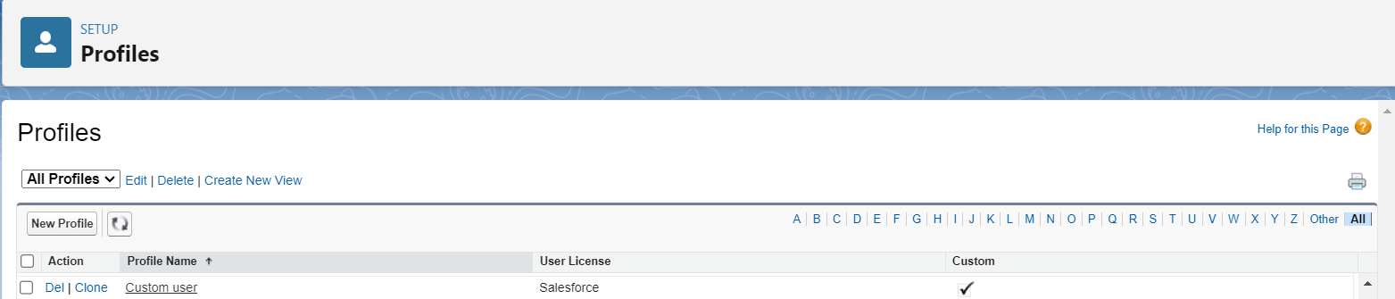

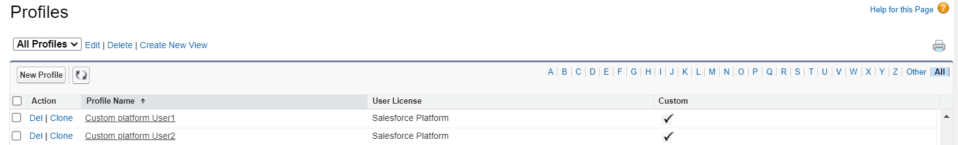

### Task 7: Roles

1. **Marketing Role**:
   * **Purpose**: Define a role for users involved in marketing activities, with access to customer data and marketing reports.
2. **Receptionist Role**:
   * **Purpose**: Set up a role for receptionists to manage room bookings, customer inquiries, and related tasks.

### Task 8: Creating Users

1. **User 1**:
   * **Role**: CEO
   * **User License**: Salesforce
   * **Profile**: Custom User

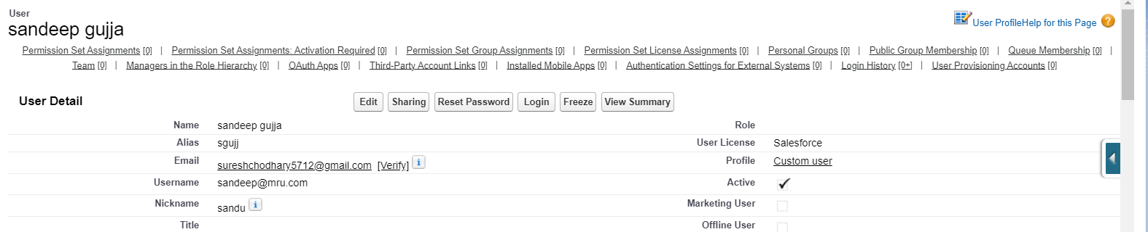

1. **User 2**:
   * **Role**: Marketing
   * **User License**: Salesforce Platform
   * **Profile**: Custom Platform User1

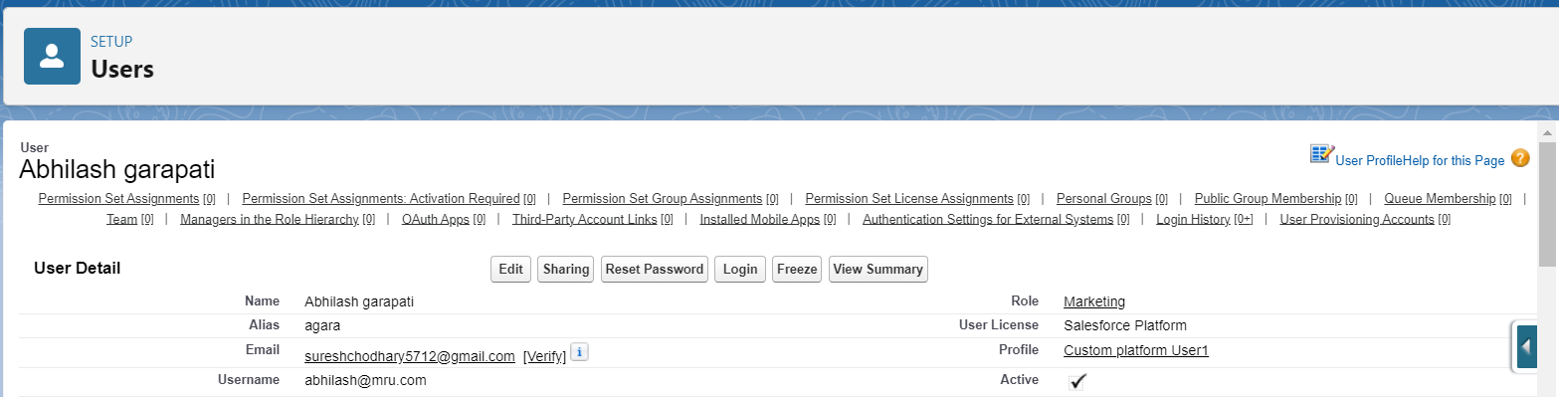

1. **User 3**:
   * **Role**: Receptionist
   * **User License**: Salesforce Platform
   * **Profile**: Custom Platform User2

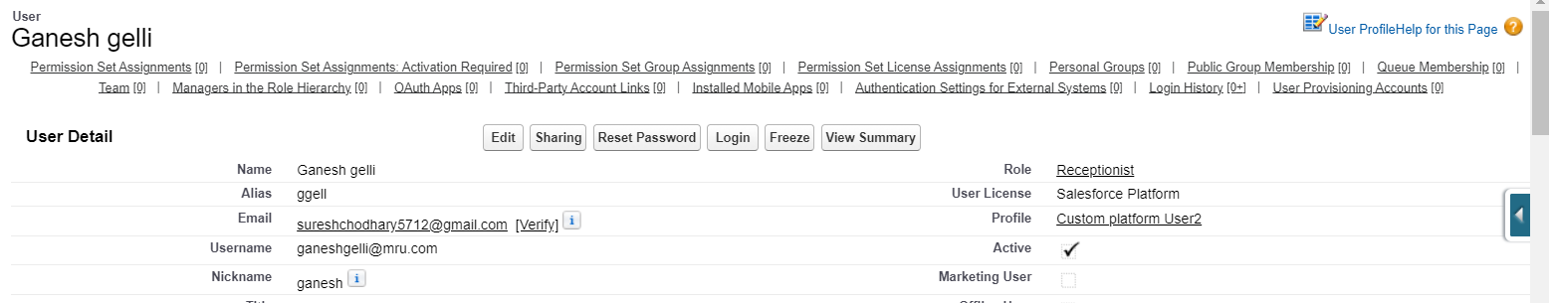

### Task 9: User Adoption

1. **Create a Record**:

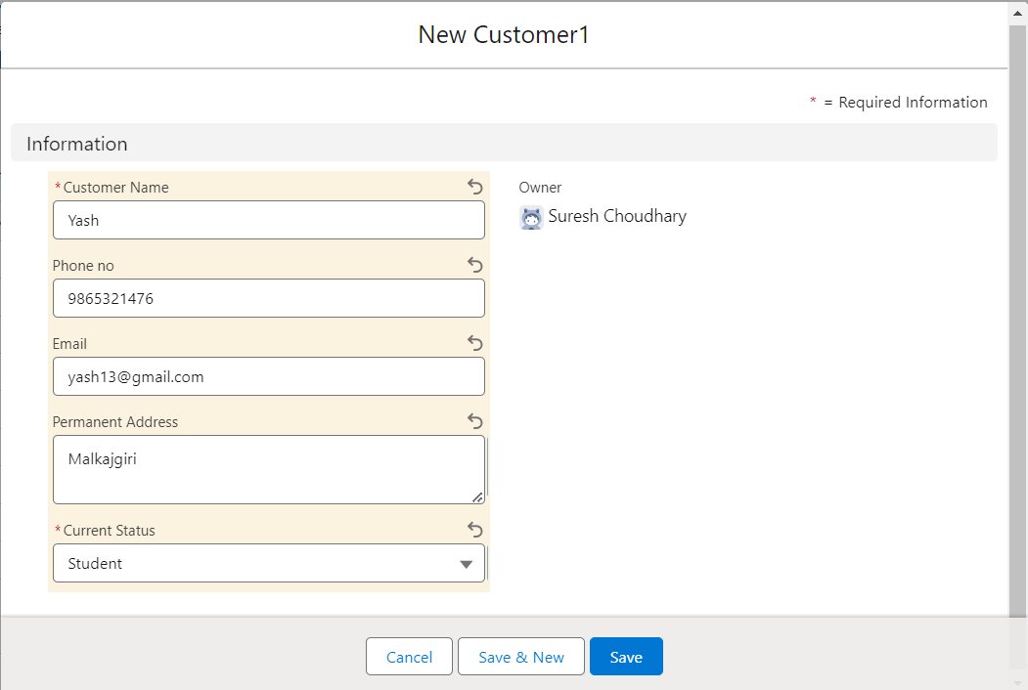

1. **View a Record**:

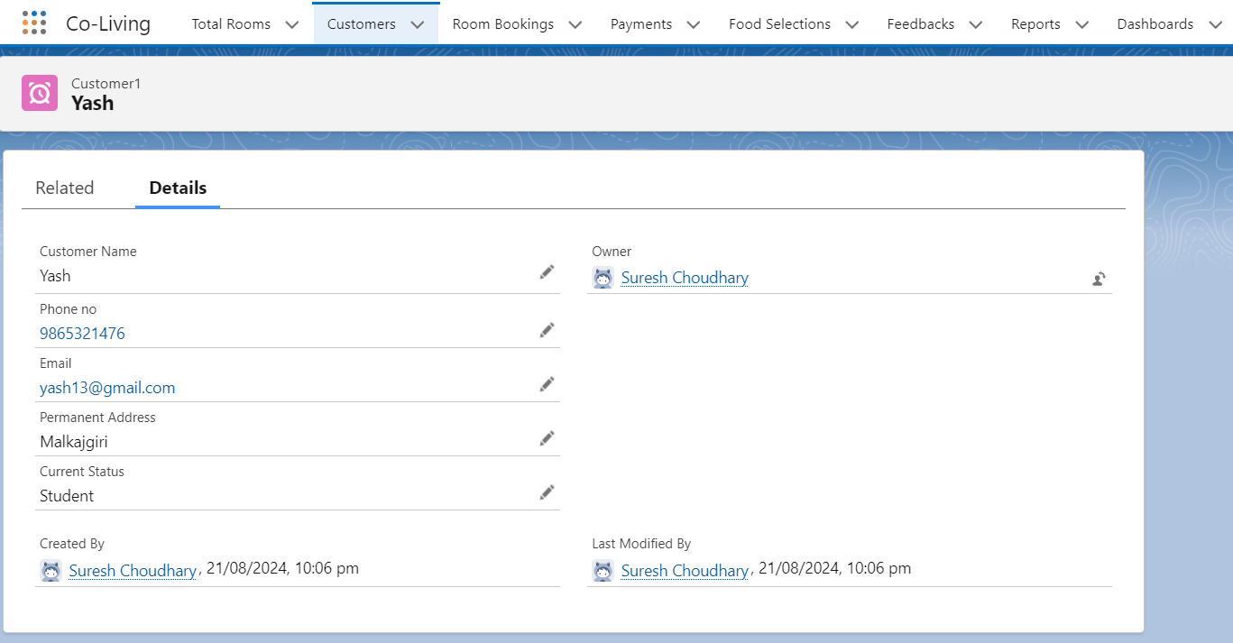

1. **Delete a Record**:

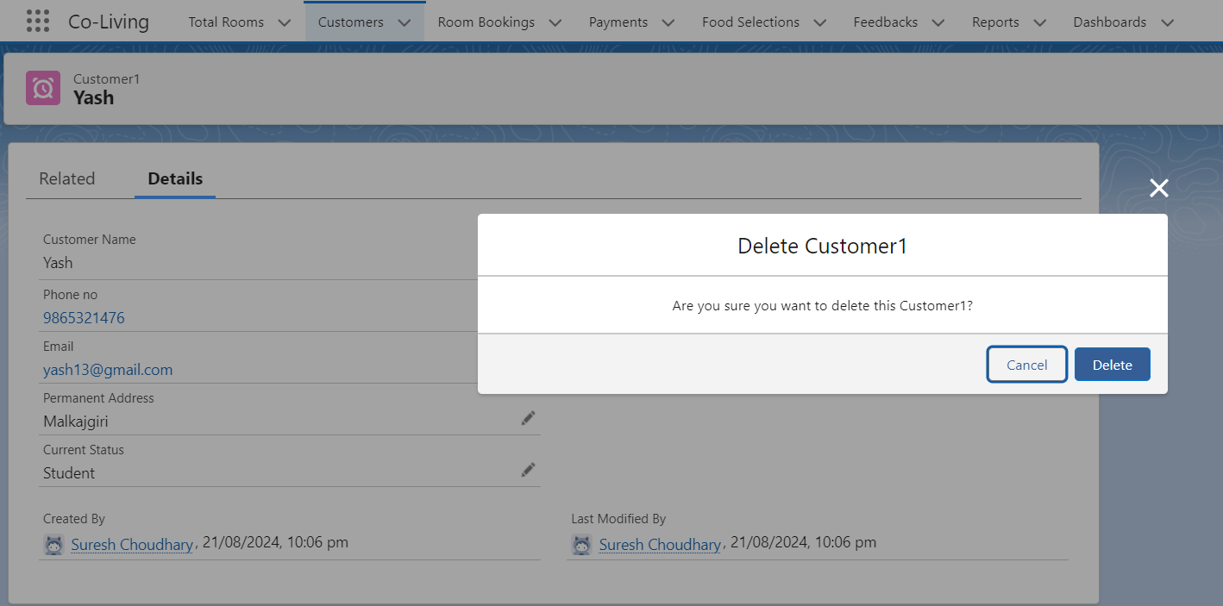

### Task 10: Create Reports

1. **Customer with Room Booking with Payments**
   * **Group Rows**: Payment Mode, Customer Name
   * **Columns**: Payment No, Room No, Total No of Rooms, Room Sharing, Advance Payment for 1 Month, Amount

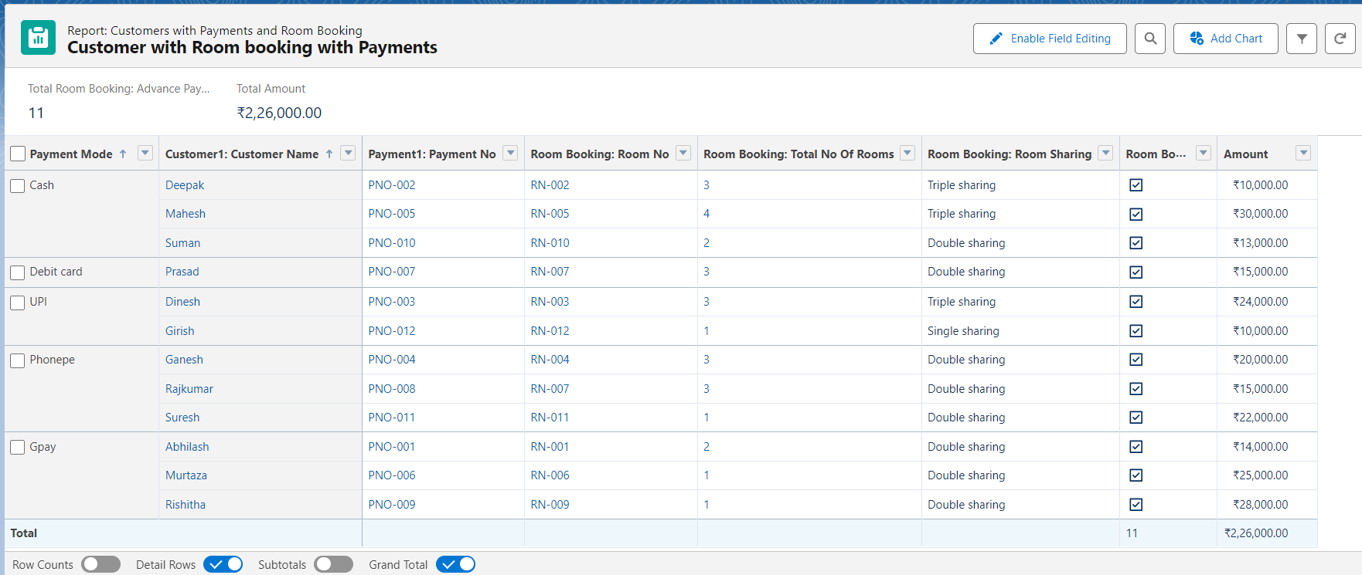

1. **Customers with Room Bookings with Total Rooms**
   * **Group Rows**: Total No of Rooms, Customer Name, Room Sharing
   * **Columns**: Amount, Rooms Booked, Rooms Available

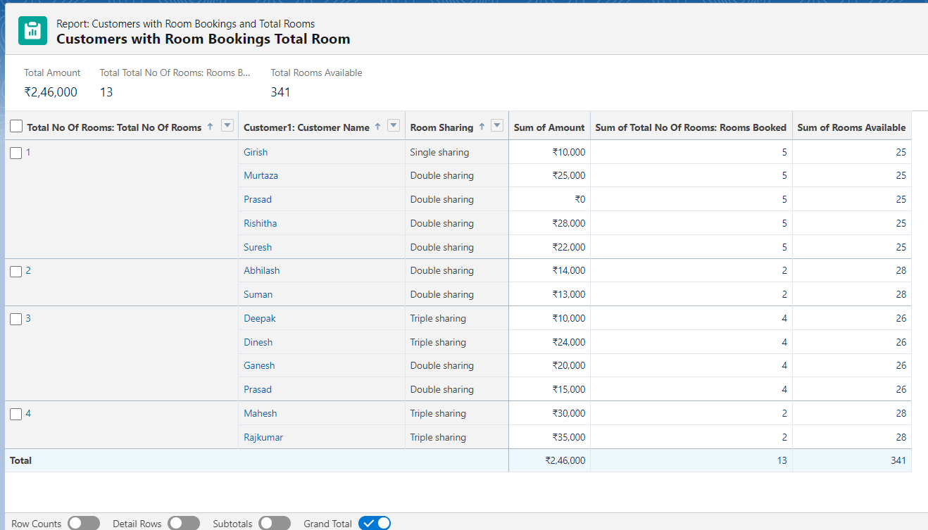

### Task 11: Creating Dashboards

**Dashboard 1 Components:**

1. **Funnel Chart**:
   * **Value**: Sum of Amount
   * **Color By**: Customer Name
   * This chart displays the total amount of payments from different customers, with each segment representing a different customer. The funnel shape helps visualize the distribution of payment amounts across customers.

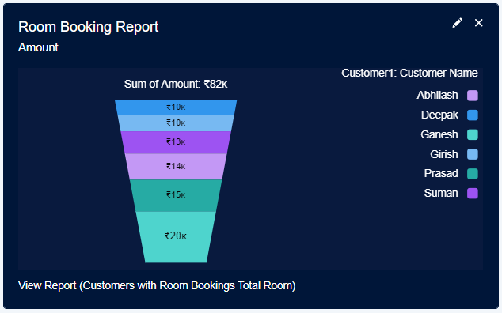

1. **Vertical Bar Chart**:
   * **X-Axis**: Total No of Rooms
   * **Y-Axis**: Sum of Amount
   * This chart shows the total amount of payments against the number of rooms. It helps visualize how payment amounts correlate with the number of rooms, highlighting trends or discrepancies.

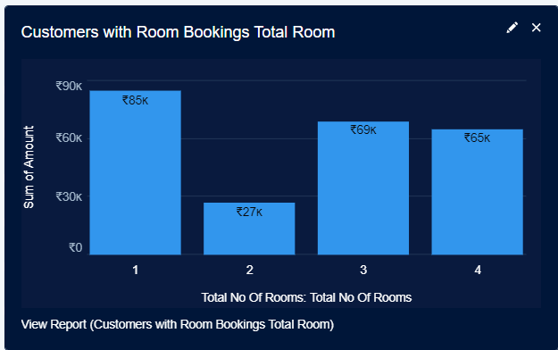

1. **Donut Chart**:
   * **Value**: Sum of Amount
   * **Sliced By**: Room Sharing
   * This chart breaks down the total amount of payments based on room sharing types. Each segment represents a different room sharing category (e.g., single, double) and shows how much each category contributes to the total amount.

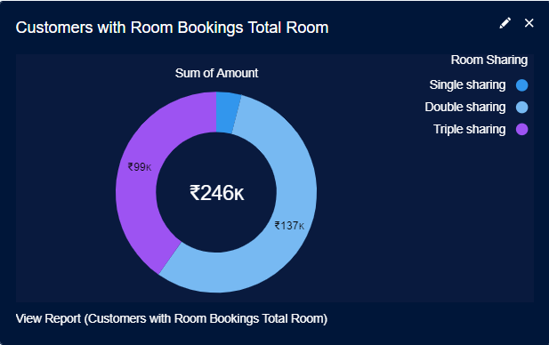

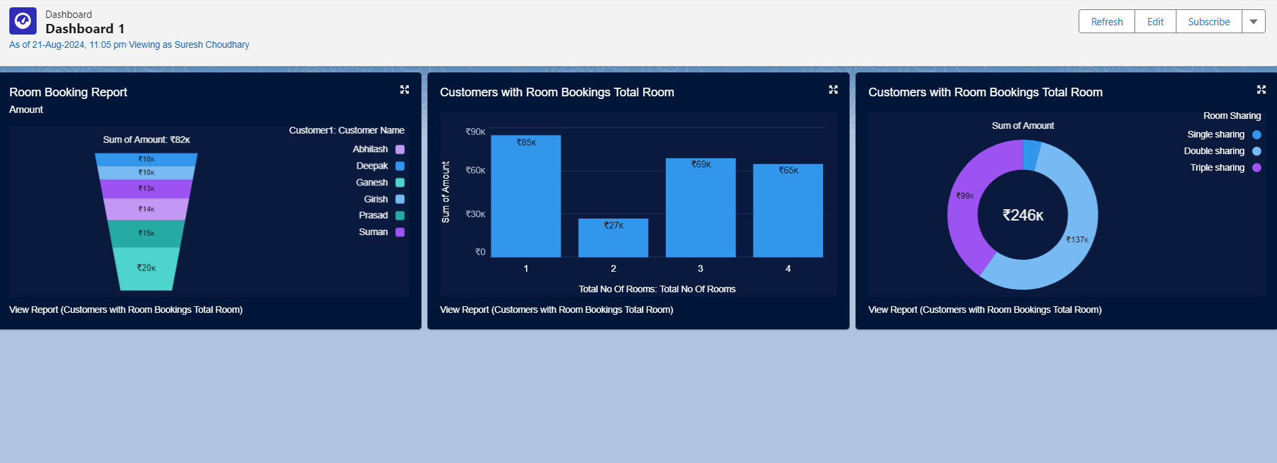

### Dashboard 2 Components

1. **Donut Chart: Room Bookings by Payment Mode**
   * **Value**: Advance Payment for 1 Month
   * **Sliced By**: Payment Mode
   * This chart shows the distribution of advance payments for room bookings, categorized by different payment modes (e.g., credit card, bank transfer). Each segment represents a payment mode and its contribution to the total advance payment amount.

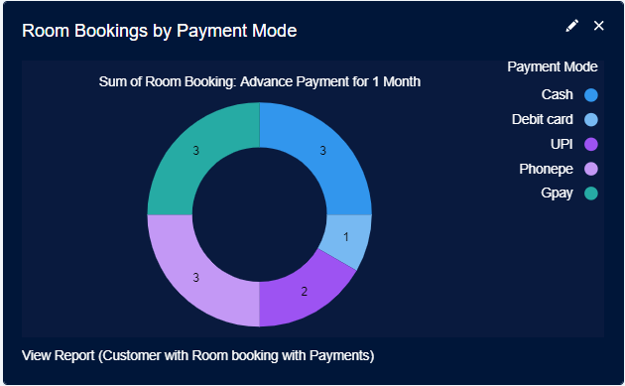

1. **Donut Chart: Distribution of Payment Mode**
   * **Value**: Sum of Amount
   * **Sliced By**: Payment Mode
   * This chart illustrates how the total payment amount is distributed across various payment modes. Each segment represents a payment mode and shows its share of the total payment amount.

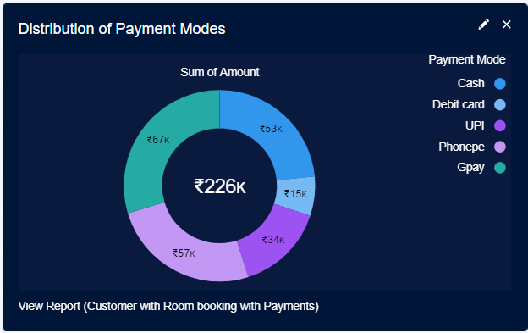

1. **Lightning Table**
   * **Groups**: Room Sharing
   * **Measure Columns**: Record Count, Amount
   * The table displays data grouped by room sharing categories (e.g., single, double). It includes columns for the number of records (e.g., number of bookings) and the total amount associated with each room sharing category.

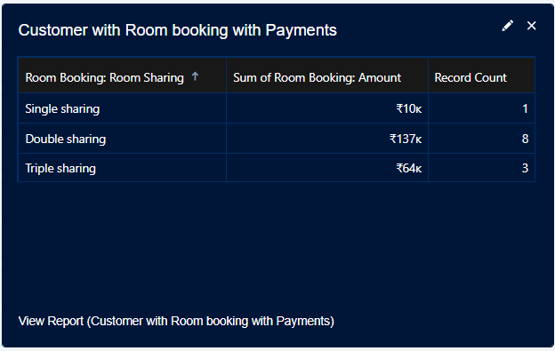

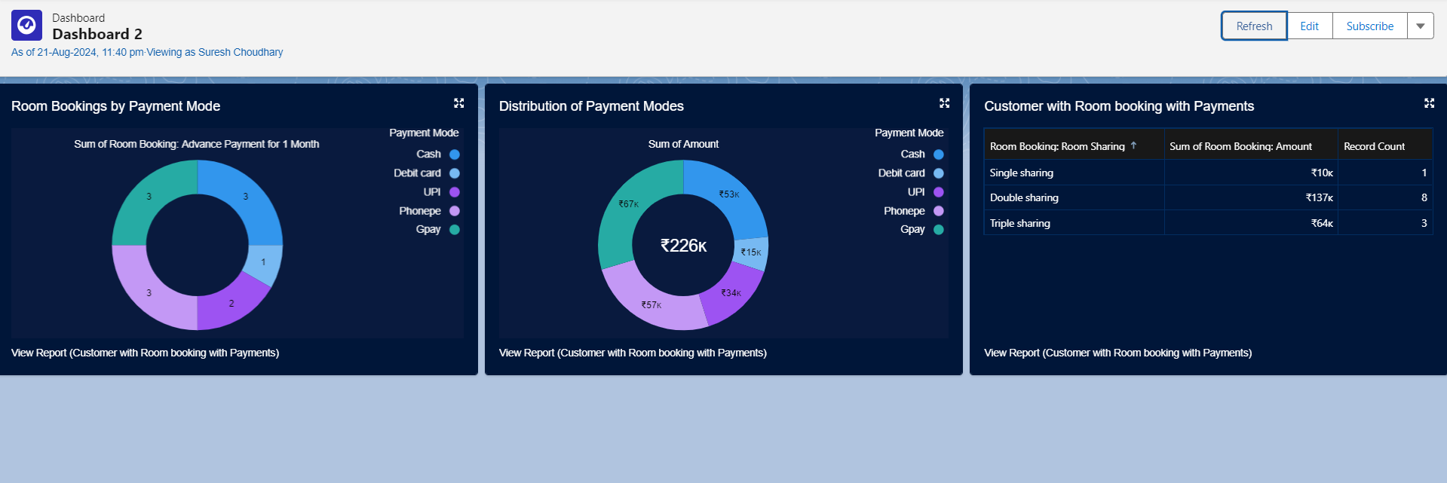

### Task 12: Flows

1. **Create a Flow**:
   * **Purpose**: Design a flow to automate a process in Salesforce, such as creating a new room booking or updating customer information.
   * **Steps**:
     + Go to **Setup** > **Flows** > **New Flow**.
     + Choose the flow type Record-Triggered Flow.
     + Add elements like screens, decision points, and actions based on your automation needs.
     + Configure the flow to handle specific tasks and save.

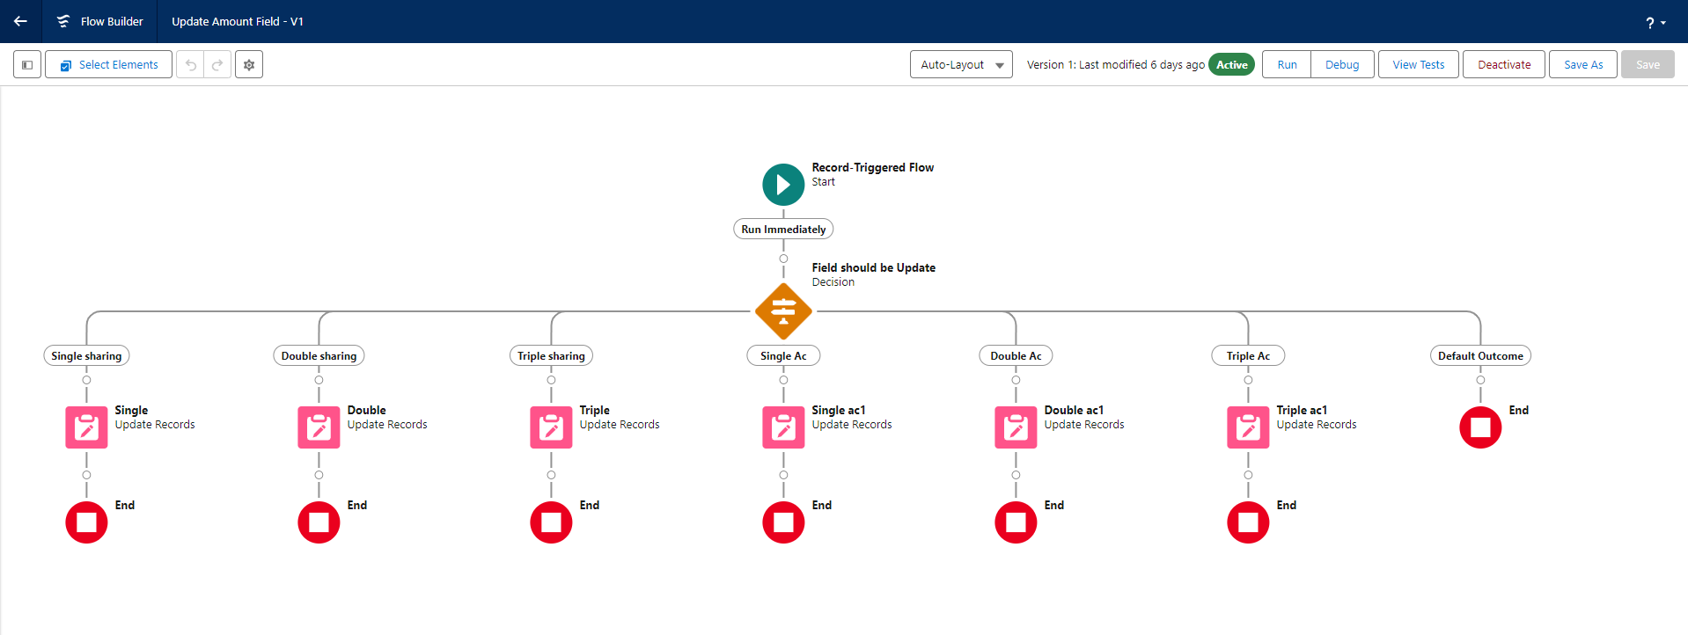

1. **Test the Flow**:
   * **Purpose**: Ensure the flow works as expected before deploying it to users.
   * **Steps**:
     + Go to App Launcher and search for Co-living and select the app
     + In the Co-living app click on the Room sharing tab and click on new.
     + Enter the details like Name, Room sharing, Ac-3000, Advance payment for 1 Month and the Amount field is empty before saving the record.

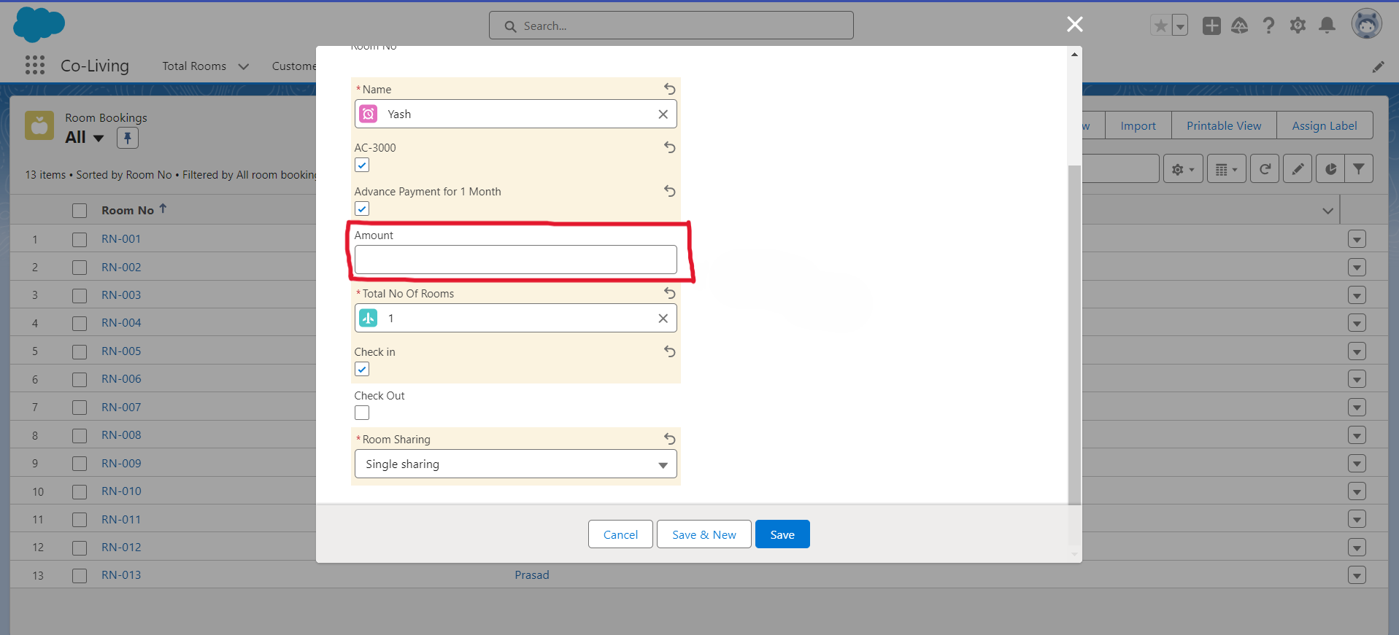

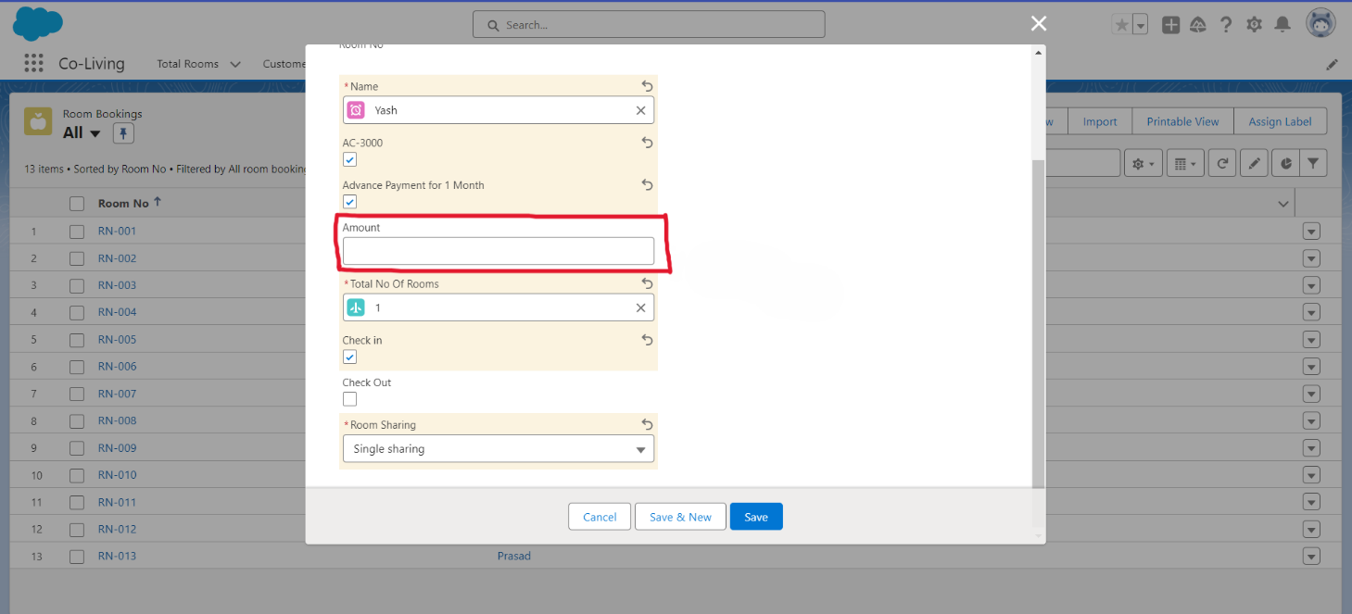

**Leaving the Amount field empty to test the Flow**

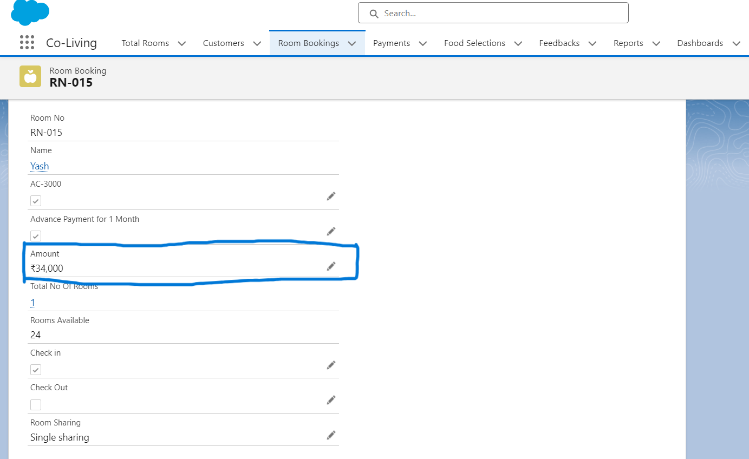

**Hence, we can see that the Amount field, when left empty, is automatically set to the default value of ₹34,000. Therefore, the flow is working correctly.**

**Thank You**